Bolton Swimming Club 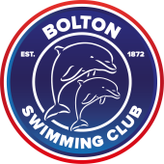
2023 – 2024 Season Club T-Shirt
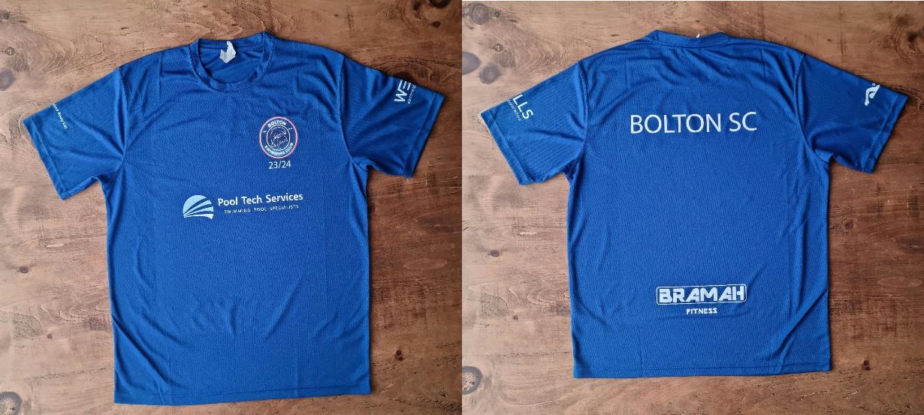

Youth sizes:
T-shirts - XS 3/4 S 5/6 M 7/8 L 9/11 XL 12/13

Adults sizes:
T-Shirts - XS 35" S 38" M 40" L 43" XL 45" 2XL 48" 3XL 50”

Club Hoodie

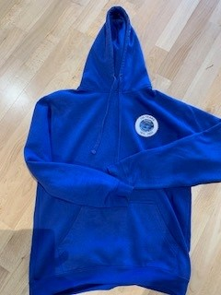

Youth sizes:
Hoodie - XS 3/4 S 5/6 M 7/8 L 9/11 XL 12/13

Adults sizes:
Hoodie - XS 35" S 38" M 40" L 43" XL 45" 2XL 48" 3XL 50”

Please click the link below to place your order
https://forms.gle/aZygeCnbaQjfWWF59

